13.1.3 Editors - Video Sequence Editor - Header - Export Menu
Export menu 2
Export Subtitles 2

Export menu

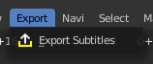
This menu exists in both view types. It currently has just one entry.

Export Subtitles

Exports the subtitles of a video in stl format. You need to have a subtitle text strip in the video.

